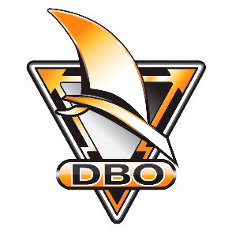



|  |  |
| --- | --- |
|  | **DBO Championship Rules for iQFOiL Open - IFCA Slalom Combined 2025**  **(DBO-CR-Combined)** |
|  | The purpose of this document is to describe the scoring of the DIF, DS, and DBO Danish Championship Series for the Combined iQFOiL Open - IFCA Slalom title. This document is to be referenced from the NoR and SI. |
| **1** | **ORGANISATION** |
| **1.1** | The Danish Championships are to be based on a series of individual regattas, organised by Sailing Clubs under the Danish Sailing Association. |
| **1.2** | The regattas to be included in the series will be published on <https://dbo.dk/foil-kurs-slalom/>. It is the intention to publish the series with at least 3 months’ notice but cancellations and changes during the season can occur. |

|  |  |
| --- | --- |
| **2.1** | The Danish Championship Combined is calculated based on the sailor's rank in the iQFOiL Open and the sailor’s rank in the combined IFCA Slalom disciplines. A sailor will not be ranked in the combined discipline, if the sailor has not started at least one race in both of the iQFOiL Open and combined IFCA Slalom disciplines.  The final rank in the iQFOiL Open and combined IFCA Slalom disciplines respectively are added to a score for the Championship Combined - regardless of the number of completed iQFOiL Open and IFCA Slalom races. |
| **2.1.1** | In case of a tie in the Combined score, the tie will be decided in favour of:   * The sailor with the best result in a single discipline (i.e., a 1st and 3rd place beats two 2nd places).   If a tie still remains, it will be decided in favour of the:   * The sailor with the best result in the discipline with the most races sailed |
| **3** | **PRIZES FOR THE CHAMPIONSHIP SERIES** |
| **3.1** | For the combined Danish Championship, prizes are expected in the following divisions, based on the number of participants: Men Women, U17, U19, U21, Masters, Grand Masters.  More specifically the titles awarded are:   * Danish Champion (DIF) for the result of Senior Combined * Danish Champion Youth (DS) for the result of the U19 Combined * Danish Champion (DBO) for the result of Combined, in the following divisions: U17, Women, Masters, Grand Masters. Additional or fewer divisions may be awarded depending on number of participants. |